FOCP ASSIGNMENT 1

MODULE 3
Ques 3
count operations to get 0
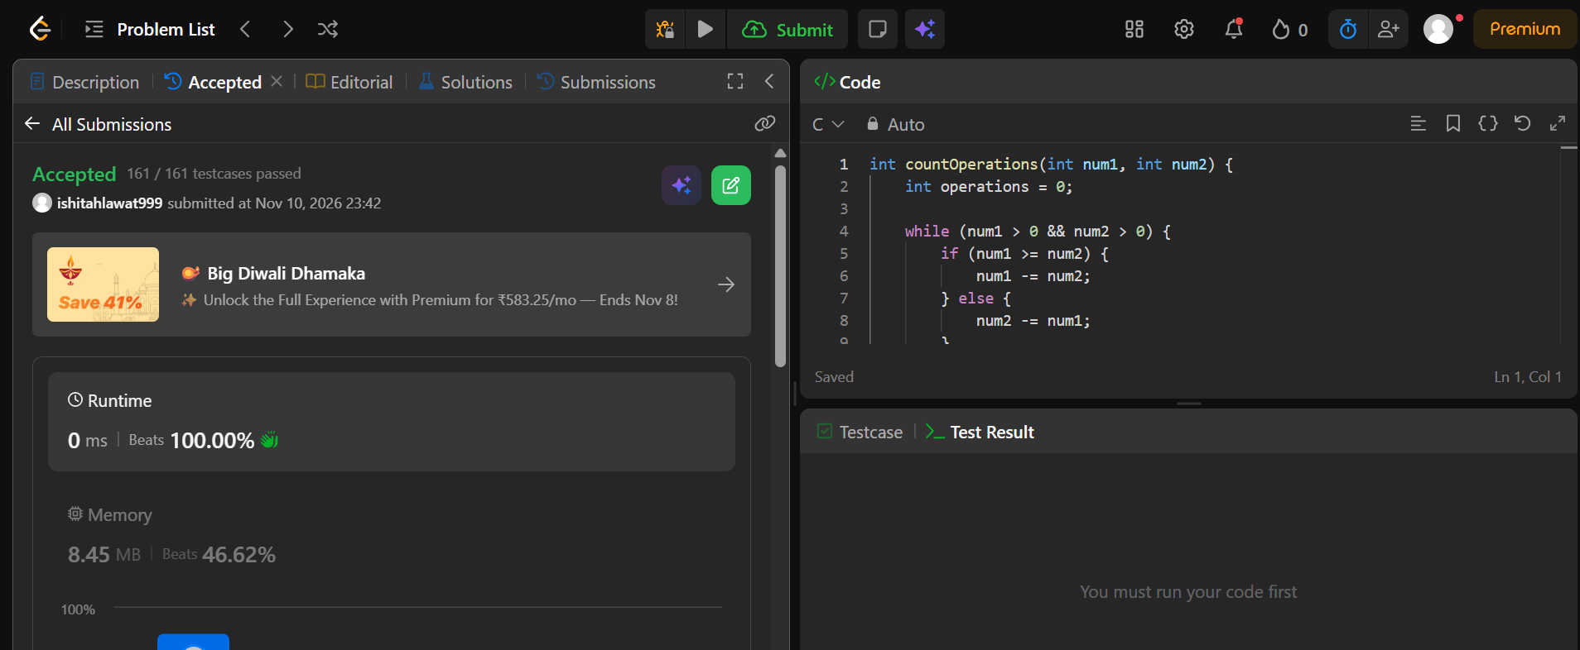

int countOperations(int num1, int num2) {
int operations = 0;

while (num1 > 0 && num2 > 0) {
if (num1 >= num2) {
num1 -= num2;
} else {
num2 -= num1;
}
operations++;
}

return operations;
}

